Logo, company name

Automatically generated description

HEMPSTEAD UNION FREE SCHOOL DISTRICT

NEW YORK STATE

MY BROTHER'S GUARDIAN SUMMER SPORTS

CAMP PROGRAM

2022

**MBK S.T.E.A.M. PRIDE**

Dear Parent/Guardian and Applicant,

Thank you for your interest in Hempstead schools

MY BROTHER'S KEEPER SUMMER ***SPORTS CAMP*** PROGRAM (MBK)

ALL ABGS MIDDLE SCHOOL STUDENTS

BOYS AND GIRLS ARE WELCOME TO JOIN

STARTSFROM JUNE 28 TO JULY 28

MONDAY -THURSDAY

1:00 PM – 3:00 PM

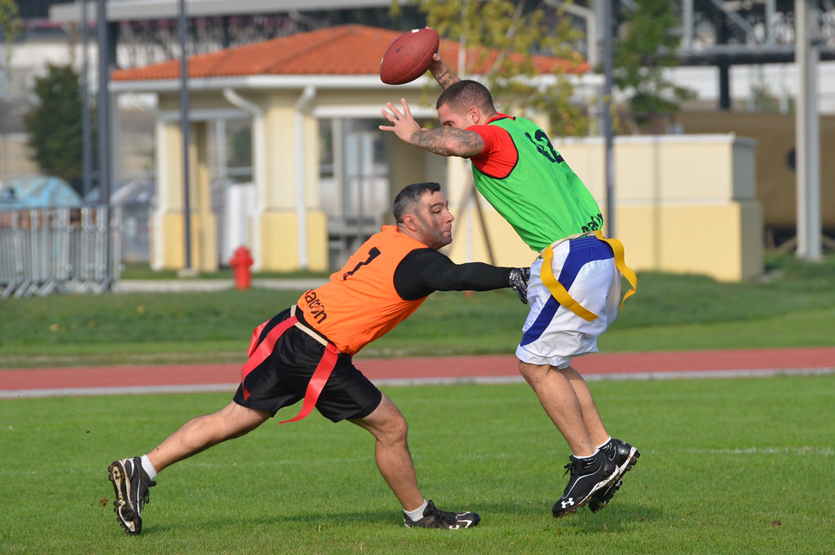

[This photo](https://www.flickr.com/photos/usagvicenza/8115786852) by unknown author is licensed under [CC BY-NC](https://creativecommons.org/licenses/by-nc/3.0/)



[This photo](https://foottalk.blogspot.com/2019/06/womens-feet-soccer-boots-and-common_18.html) by unknown author is licensed under [CC BY](https://creativecommons.org/licenses/by/3.0/)

Playing sports is wonderful, but it's even better to WIN! As they strive to win, children learn about teamwork , leadership , and sportsmanship, all of which can contribute to their development as strong citizens. These lessons will translate directly into the classroom and beyond. Please join in to learn and have fun.

Any questions, please contact:

Stacey Corvi – Director of MBK in [scorvi@hempsteadschools.org](mailto:scorvi@hempsteadschools.org)

Please fill out the application form in full:

Student/Applicant Name: _________________________________________________________________

(LAST NAME) (FIRST NAME)

Gender: ___MALE ______FEMALE Grade: _______ Student ID #: _______________

Name of the Guardian/Mother: ___________

Work Phone: _________________ Work Phone: _________________

Cellphone: ___________________ Cellphone: ___________________

Email: _______________________ Email:_____________________

* I do NOT give permission for my child to be photographed for the purposes of the program

**__________________________ ______________**

**Signature of parent/guardian Date**

**CIRCLE YOUR SPORTS CHOICE:**

**FLAG FOOTBALL. SOCCER**